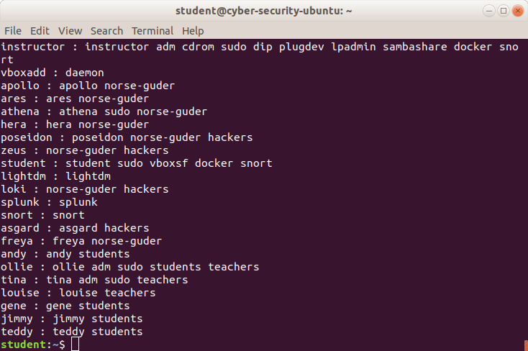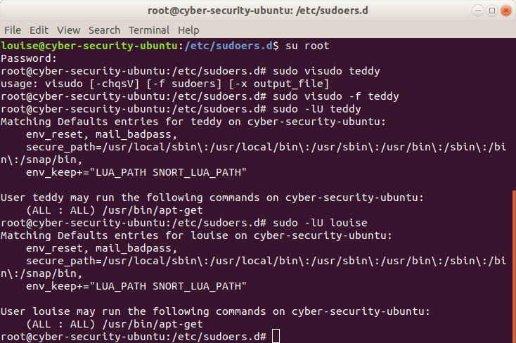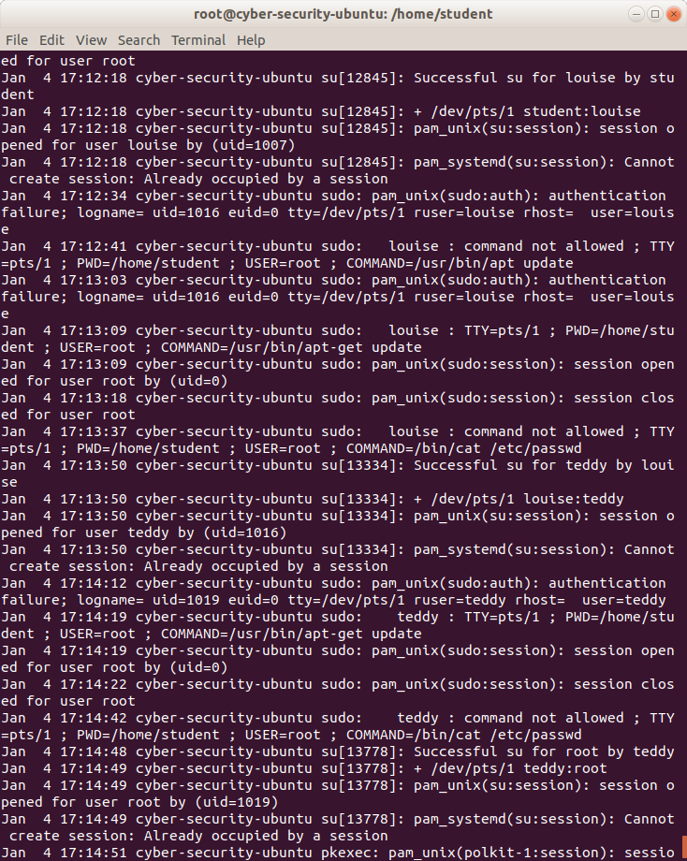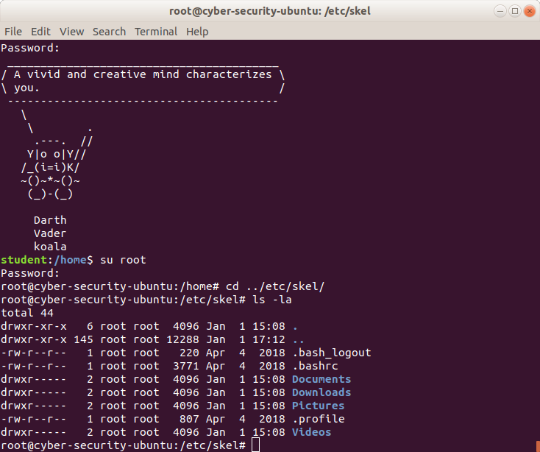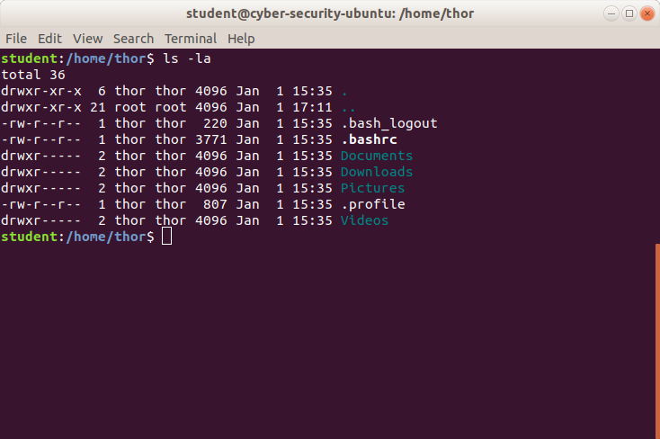

Here I am giving Louise the right to only run apt-get

Here I am giving Teddy the right to only run apt-get

You can see I created the 7 users, Andy, Ollie, Tina, Louise, Gene, Jimmy, and Teddy. I created the group teachers and put Ollie, Tina and Louise in that group and then put the rest in the students group including Ollie. Next, I gave Tina and Ollie sudo rights

Successful sudo attempt to update

Insufficient permissions to cat the password directory

Failure to enter in teddy’s password for sudo

Switch over to teddy

Insufficient permissions to cat the password directory

Successful sudo attempt to update

Failure to enter in louise’s password for sudo

Switch over to louise

Updated Skel Directory so that new users will automatically have Documents Downloads, Pictures and Videos when their profile is made.

New user Thor created after the Skel directory got updated